**DESIGN MODEL**

Table of Contents:

Summary Page 1

Static View Page 2

Dynamic View Page 3

**Summary (REVISED)**

This document shows how we are mapping our software more specifically. The static view shows our separate classes and their objects, and the dynamic view shows how the different classes interact with each other. Our primary classes are: Game, Game board, Player, Resource, and Building. Our Login class is a stub class that has very little interaction in the system outside of player validation.

**Static Diagram View (REVISED)**

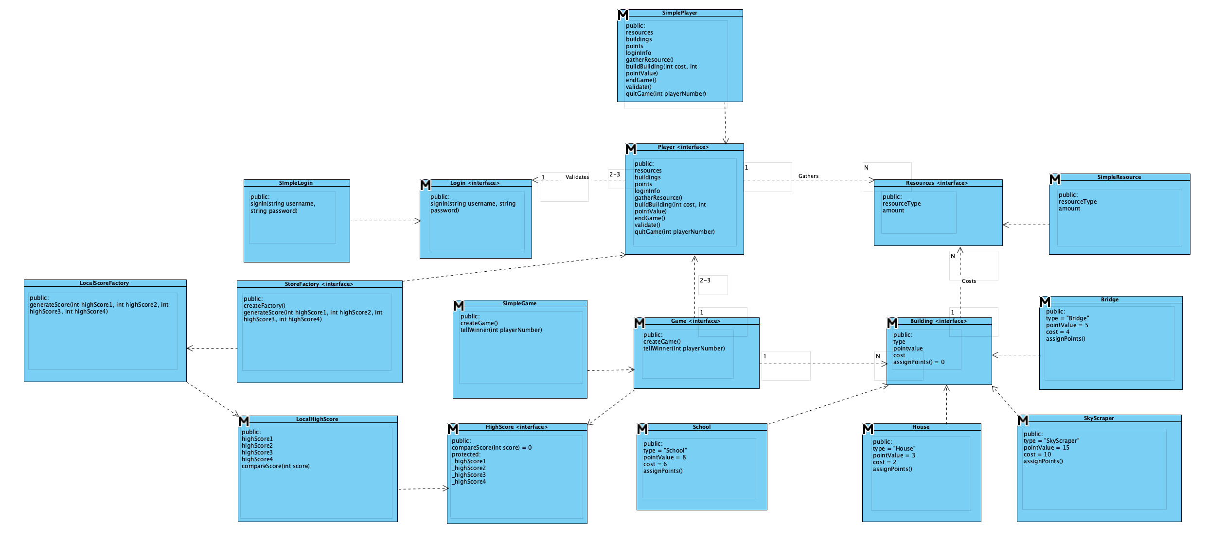

**Dynamic View (REVISED)**

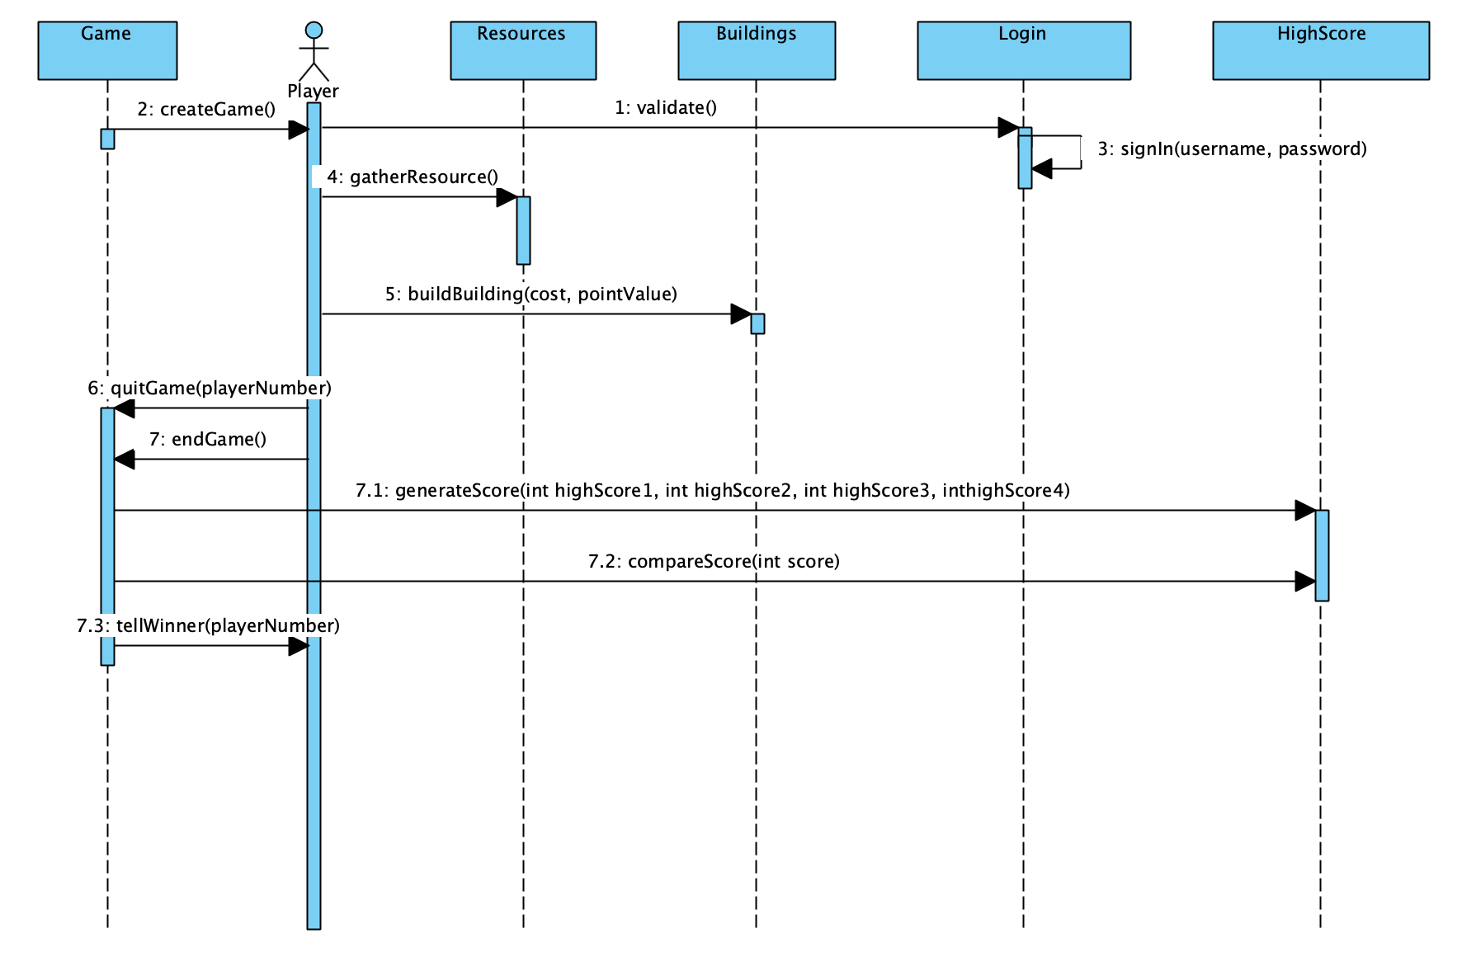

|  |  |  |
| --- | --- | --- |
| Date | Phase | Info |
| 10/01/18 | Inception | N/A |
| 10/29/18 | Elaboration 1 | Initial Design Model with dynamic and static view |
| 12/08/18 | Elaboration 2 | Updated our summary, and changed DYnamic view SSD to implement high score, and remove gameboard class. |